



MICROSOFT ARCHITECTURE BEST PRACTICE FOR AI BUSINESS PROCESS
USECASE: AUTOMATE PDF FORMS PROCESSING

Document Title | Microsoft Cloud Center of Excellence Overview
Presales/Technical Head | Tushar Mehrotra/Rohit Pandey
CCoE Lead | Ravishankar N
Creation Date | 23rd January 2026
Version | Description | Modified by | Date | Approved by | Date
1 | Draft architecture baseline for review | Sharmila Devi K | 15/01/2026 | Ravi Shankar | 15/01/2026
2 | Updated draft with architecture refinements and review comments | Sharmila Devi K | 19/01/2026 | Ravi Shankar | 19/01/2026
3 | Final approved architecture design | Sharmila Devi K | 23/01/2026 | Ravi Shankar | 23/01/2026
Contents

1. Executive Summary 3
2. Scope and Applicability 3
3. Business Scenario Overview 3
4. Reference Architecture Overview 4
4.1 Architecture Description 4
5. Logical Architecture Components 4
5.1 Ingestion Layer 4
5.2 Processing Layer 5
5.3 AI Extraction Layer 5
5.4 Storage and Analytics Layer 5
6. Architectural Best Practices 6
6.1 Azure Well-Architected Framework Alignment 6
6.2 Governance & Operational Controls 6
6.3 Security and Compliance 6
7. Cloud Center of Excellence Enablement Model 7
8. Reusability and Scalability 7
9. Conclusion 7

Automate PDF Forms Processing

Executive Summary
This document defines the standardized reference architecture and architectural best practices governed by the Cloud Center of Excellence (CoE) for delivering automated PDF forms processing solutions on Microsoft Azure.
The architecture leverages Azure AI Document Intelligence, Azure Logic Apps, Azure Functions, Azure Data Lake Storage, Azure Cosmos DB, and Power BI to replace manual and inflexible document processing workflows with an automated, scalable, and AI-driven solution.
This document serves as audit-ready evidence of Cloud Center of Excellence capability, fulfilling the requirements defined in Frontier Distributor checklist – Section 3.1.1.

Scope and Applicability
This reference architecture applies to:
- CSP distributors and reseller-led services
- Intelligent document processing workloads
- PDF-based forms such as applications, claims, invoices, and registrations
- SMB, Mid-Market, and Enterprise customers
- Regional and global CSP authorization models
The architecture supports repeatable deployment and governance across regions, as required for Frontier Distributor eligibility.

Business Scenario Overview
Organizations frequently receive PDF-based forms through email or file uploads, which require manual review, data extraction, and downstream processing. These manual processes are costly, error-prone, and slow.
Automated PDF forms processing enables:
- AI-based extraction of structured data from PDF forms
- Reduction of manual data entry
- Faster processing and decision-making
- Integration with analytics and reporting platforms
Microsoft’s reference architecture demonstrates how Azure services can automate these workflows end-to-end.

Reference Architecture Overview

4.1 Architecture Description
The solution implements an event-driven, serverless document processing pipeline, where:
- PDF forms are received via email or uploaded to storage
- Azure Logic Apps orchestrate workflow triggers
- Azure Functions perform document splitting and processing
- Azure AI Document Intelligence extracts structured data
- Extracted data is stored for analytics and reporting
This pattern provides scalability, flexibility, and cost efficiency.
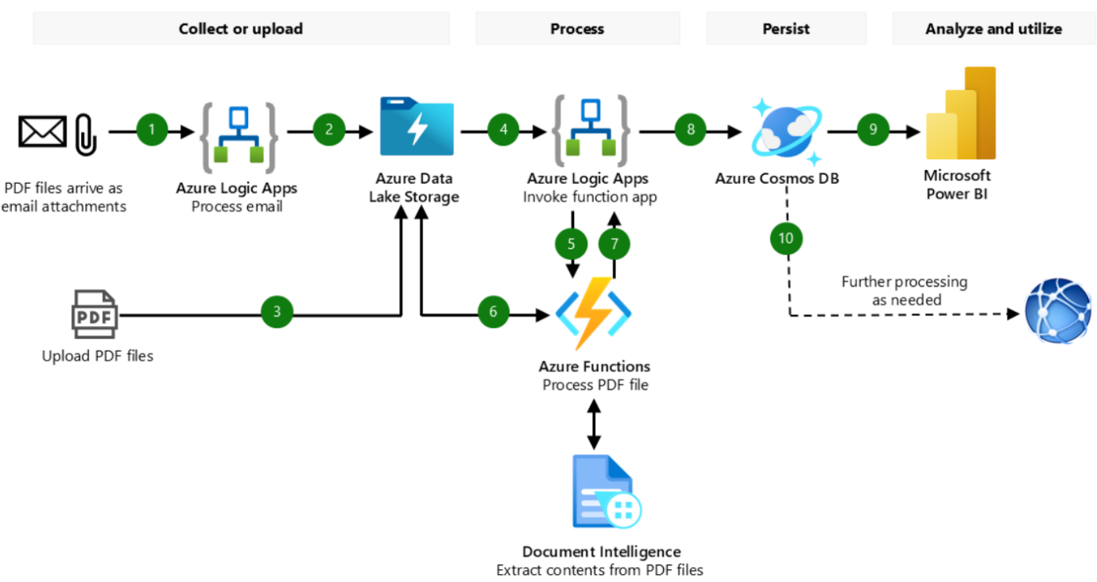

Logical Architecture Components

5.1 Ingestion Layer
Email or File Upload
- Designated Outlook mailbox or application uploads
- Triggers automated workflows
Azure Logic Apps
- Serverless orchestration service
- Detects incoming emails or file uploads
- Routes documents to downstream processing components

5.2 Processing Layer
Azure Data Lake Storage Gen2
- Stores raw PDF files
- Persists split pages and processed outputs
- Supports scalable, low-cost storage
Azure Functions
- Serverless compute for document handling
- Splits multi-page PDFs into individual forms
- Calls Azure AI Document Intelligence APIs
- Creates structured JSON output files

5.3 AI Extraction Layer
Azure AI Document Intelligence
- Extracts text, key-value pairs, tables, and form fields
- Supports both prebuilt and custom models
- Returns structured results suitable for downstream processing

5.4 Storage and Analytics Layer
Azure Cosmos DB
- Stores structured form data
- Enables fast querying and integration
Power BI
- Connects to Cosmos DB
- Delivers dashboards and insights from processed forms

Architectural Best Practices

6.1 Azure Well-Architected Framework Alignment
Pillar | Implementation Approach
Reliability | Serverless services with built-in resiliency
Security | RBAC, managed identities, encrypted storage
Performance | Event-driven processing and autoscaling
Cost Optimization | Consumption-based Logic Apps and Functions
Operational Excellence | Automated pipelines and monitoring
The architecture aligns with Microsoft’s well-architected editorial guidance for intelligent document processing

6.2 Governance & Operational Controls
- Centralized workflow definitions in Logic Apps
- Version-controlled Function code
- Consistent data schema validation
- Monitoring via Azure Monitor and Application Insights
These controls ensure repeatable and auditable document processing workflows.

6.3 Security and Compliance
- Secure ingress and storage of PDF documents
- Restricted access to Document Intelligence endpoints
- Encrypted data at rest and in transit
- Separation of environments (dev/test/prod)
The architecture supports compliant handling of business-critical documentation.

Cloud Center of Excellence Enablement Model
The Cloud Center of Excellence:
- Owns and governs document processing reference architectures
- Maintains reusable templates and patterns
- Defines architectural standards and security baselines
- Enables resellers with best practices and documented guidance
- Ensures consistency across regions and customer engagements
This operating model satisfies Cloud Center of Excellence requirements defined in Frontier Distributor checklist Section 3.1.1.

Reusability and Scalability
This reference architecture:
- Scales automatically with document volume
- Supports a wide range of PDF-based form scenarios
- Is reusable across industries (finance, healthcare, legal, public sector)
- Enables through-channel and co-delivery models

Conclusion
This Cloud Center of Excellence reference architecture demonstrates a Microsoft-aligned, audit-ready, and repeatable implementation model for automated PDF forms processing on Azure. It enables distributors to deliver intelligent document processing solutions while maintaining governance, security, and operational excellence across the partner ecosystem.

